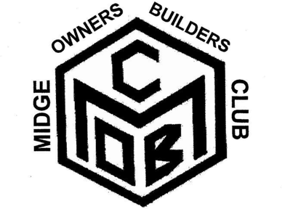
Secretary. Jim Hewlett, The Old Manse, Tarbrax, West Calder, West Lothian. EH55 8XD Tel 01501785206
This MOBC application form can be emailed or printed and posted. Attach a photo if you can, (of your car).

MOBC Application Form

Your Name
Address Line 1
Line 2
Line 3
Line 4
Postcode
Mobile Number
Email
Your Midge
Reg No
Donor make
Donor vehicle model
Engine size
Special features
( ) | <<<For a Facebook invitation put an X there

There is a £10 registration fee. (No annual fee at present)
*A bank to bank transfer can be sent to the MOBC account. It is in my name (James Hewlett) at the co-operative bank. Branch code 08-90-66 and Acc no 01047208. (Include your name so I know who sent it) This is the best method, as it goes straight to the club’s coffers.

*You can send money by Paypal using my email address jim@jimhewlett.com or my mobile phone number 07766011877. Remember to mark it gift rather than a business transaction. Otherwise Paypal takes a slice

- Send a cheque, payable to Jim Hewlett, to The Old Manse, Tarbrax, West Calder, West Lothian. EH55 8XD. Make them out to me. Jim Hewlett, not MOBC.
Thanks, Jim Hewlett Sec MOBC
If there are ways in which you could help the club, feel free to mention them below.

